Recommendations from the
Ad Hoc GCKY Natural Disaster Re-Leaf Fund Committee to the GCKY Executive Committee on Monday, March 13, 2023

►Recommendation #1:

Recommend the establishment of a GCKY Natural Disaster Re-Leaf Fund Committee. Committee will receive and review applications and make recommendations to the GCKY Executive Committee for expenditures of the Natural Disaster Re-Leaf Fund. Committee will consist of one representative from each district, appointed by the GCKY President. Upon receiving the progress and final reports, committee will provide publicity information for the GCKY Bulletin, website and other social media. Maintain an on-going summary (example attached) of all applications and provide historical information to next administration.

►Recommendation #2:

Recommend the approval of the attached GCKY Natural Disaster Re-Leaf Fund Guidelines and Application Form, dated February 2023.

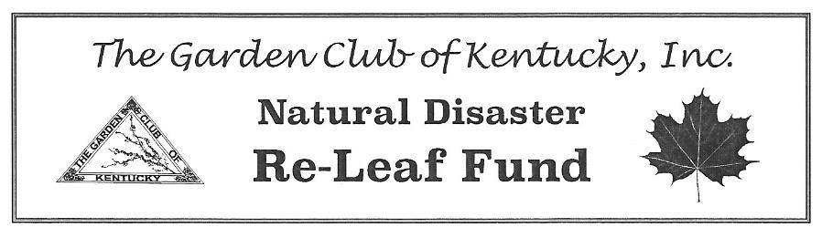 Guidelines

- Restoration project of public land as the result of a natural disaster is to be sponsored by a Garden Club of Kentucky (GCKY) Garden Club(s) in good standing.

- Applications will be reviewed by the GCKY Natural Disaster Re-Leaf Fund Committee. Funds will be distributed based on the scope of the restoration project, the number of applications received and the funding available.

- Funds provided are for the purchase of trees, shrubs, plant materials, soil amendments, and mulch. Funds are not provided for professional landscaping fees, hardscapes or equipment.

- Clean up and restoration will be provided by the Garden Club applicant and local service organization unless exceptions are approved by GCKY Natural Disaster Re-Leaf Fund Committee.

- Final Report: Within two months of project completion, submit the following to the Chairman, GCKY Natural Disaster Re-Leaf Fund Committee:

  - A short one-page report describing the project including photos
  - A copy of the final financial report including all income and expenses
  - A copy of any publicity
  - State, if permission has been given for use of photos by GCKY in print or on social media. A release form for adults and minors can be found in Forms Library section of the National Garden Club (NGC) website at https://gardenclub.org/school/forms-library.

- GCKY request any unused funds at the completion of the restoration project be returned to the GCKY Natural Disaster Re-Leaf Fund. If funds are not used within 18 months of approval, funds must be returned to GCKY Natural Disaster Re-Leaf Fund.

- Applications can be submitted at any time. Applications received before February1st will be notified by March 31st; applications received before May 1st will be notified by June 30th; applications received before August 1st will be notified by September 30th and applications received before December 1st will be notified by January 30th. Exceptions to this timeline can be granted by GCKY Natural Disaster Re-Leaf Fund Committee.

Evaluation Information

- All applications are reviewed by the GCKY Natural Disaster Re-Leaf Fund Committee with funds approved by the GCKY Executive Committee.
- Evaluation is based on the information contained in the application.
- Evaluation is based on the following Scale of Points:

Emphasis on native plant material |  | 35
Impact and scope of project |  | 35
Involvement and participation by club members |  | 15
Collaboration with other community groups |  | 15
Total 100

Application Form

Application Date: ______________________ Natural Disaster Date: __________________________

Restoration Project Location: ___________________________________________________________

Estimated Dates of Project: Beginning: _____________________Completion: ___________________

Garden Club: __________________________________ District: _____________________________

Applicant Name: _______________________________ Email: ______________________________

Address: ___________________________________________________________________________

Home Phone: _______________________ Cell: _______________________Text: _____Yes _____No

Project Contact (if different from above): _________________________________________________

Applicant Name: _______________________________ Email: ______________________________

Address: ___________________________________________________________________________

Home Phone: _______________________ Cell: _______________________Text: _____Yes _____No

Please use separate sheet and list the following:

- Nature and severity of disaster
- Location of area to be restored; please include a photo
- Proposed landscape plan (does not need to be professionally drawn) and scope of project
- Estimate of itemized costs of your project
- Other funds received toward restoration project
- Other organizations that may be involved in the project
- If sufficient funds are not raised for this project, what plans does the garden club have for completing the project?

By submitting this application, I agree to provide a progress report at the middle point of the project and a final report within two months of project completion.

_______________________________________
Signature

Email or Mail Completed Application to:

Chairman, GCKY Natural Disaster Re-Leaf Fund Committee
Form Date: February 2023

